Display Countries Belonging to SAARC

Running on server localHost 8008

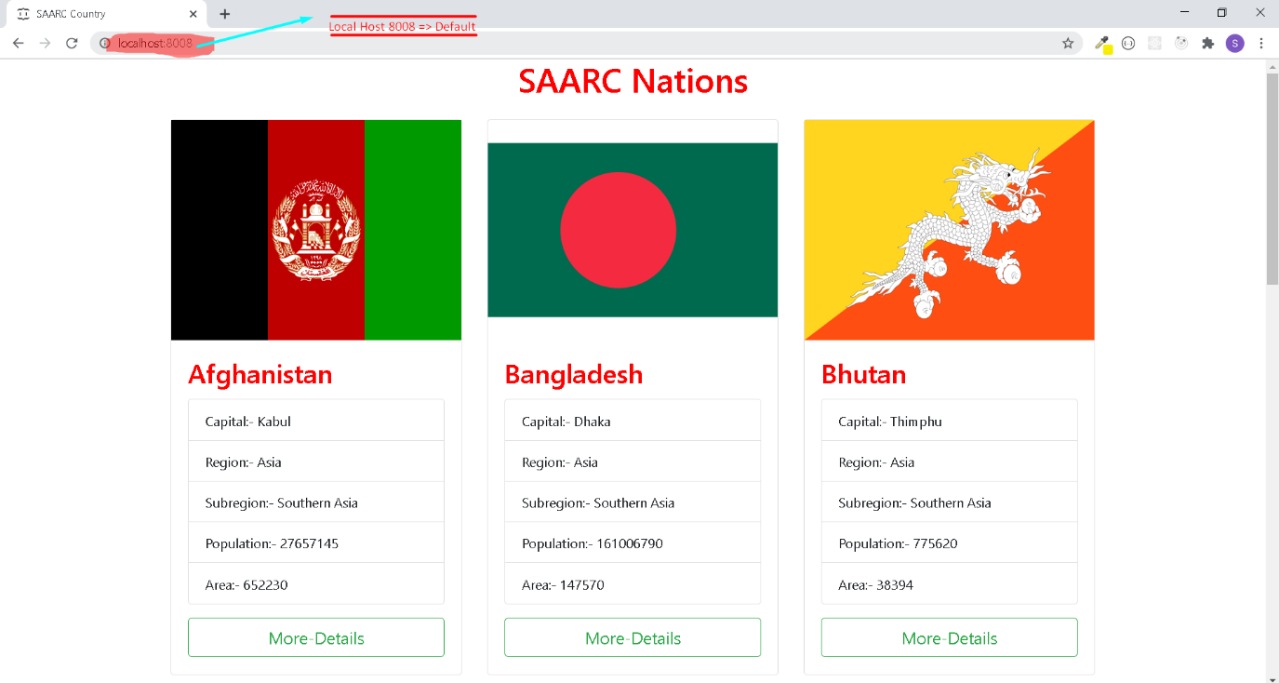

Made Use of static api (json file)

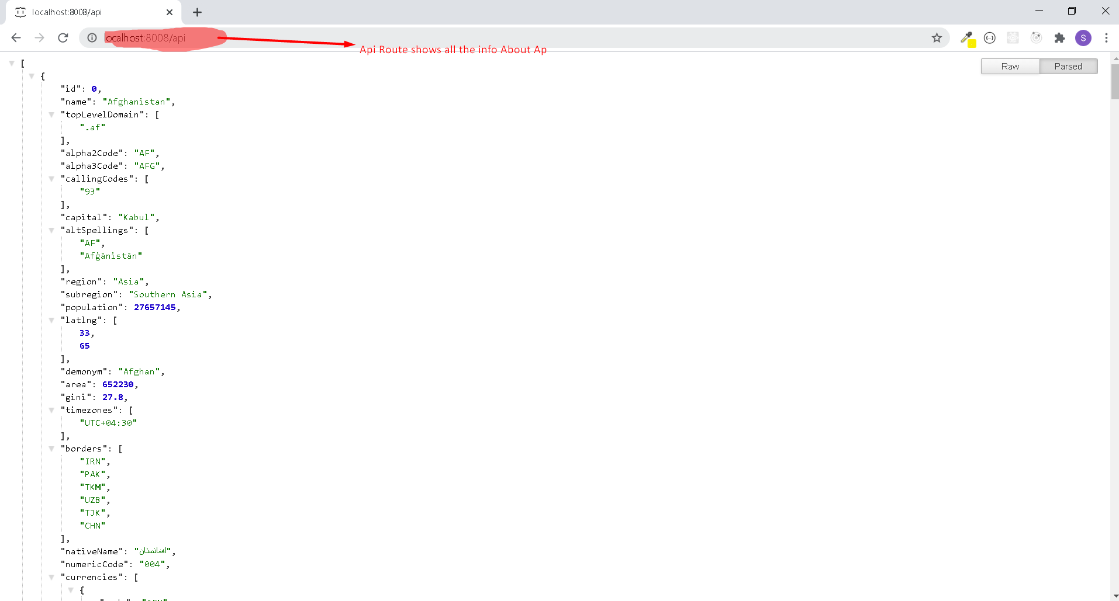

Invalid Route returns Page Not Found

/api returns api

/ or /overview returns all countries

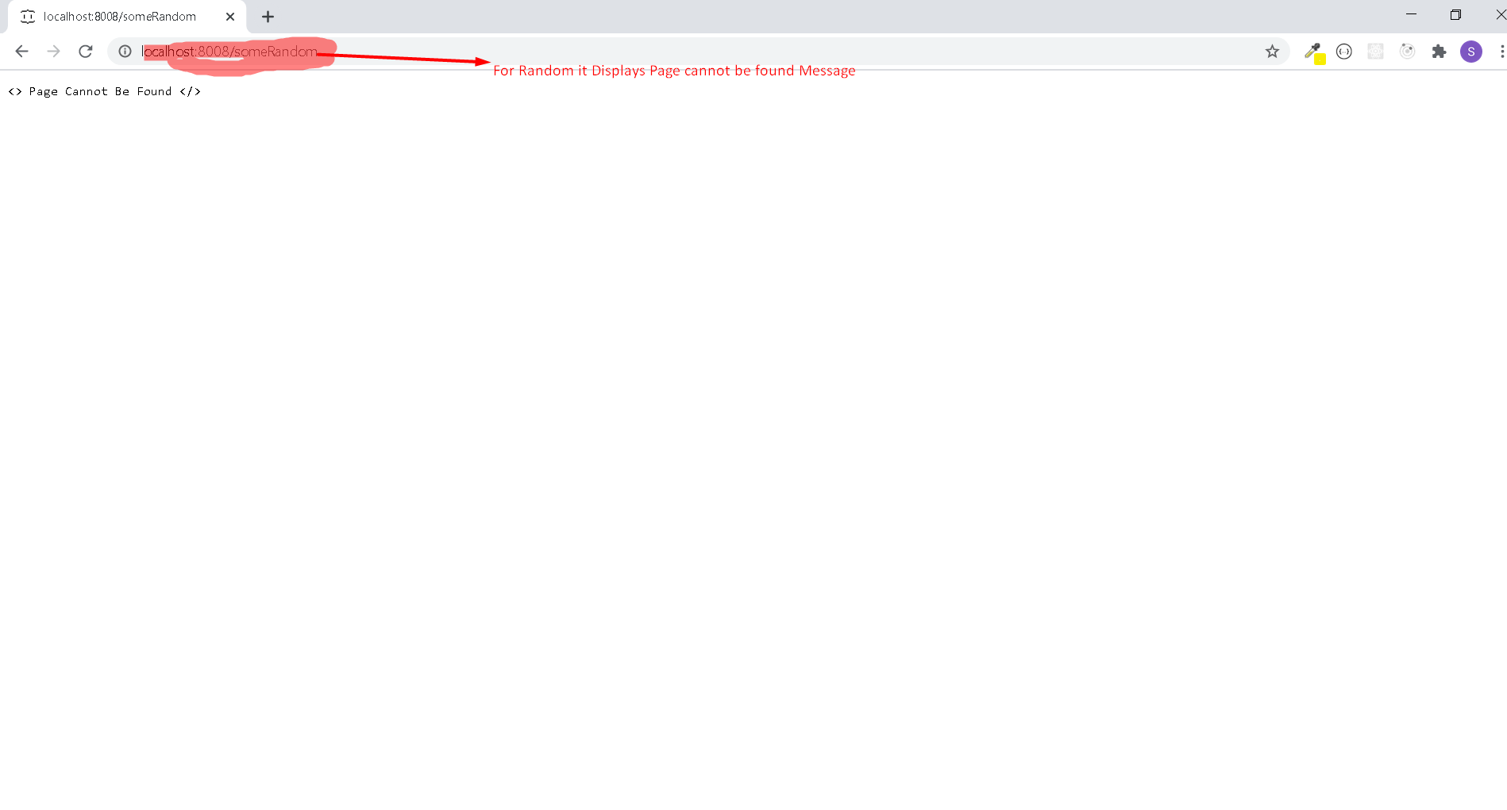

Below down route returns us a new Page with some country Info

Route is Dynamic

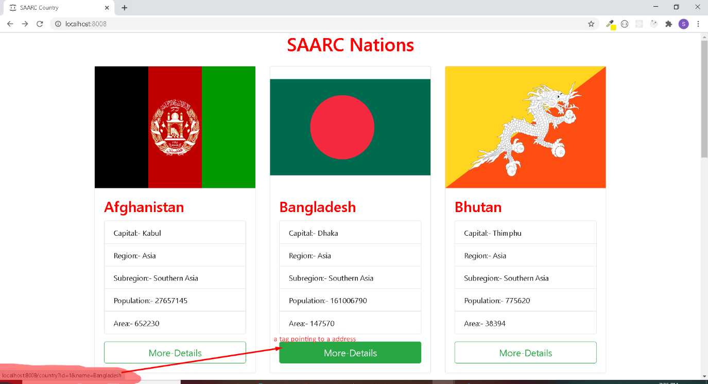

The url display a page with some country Information and country Borders

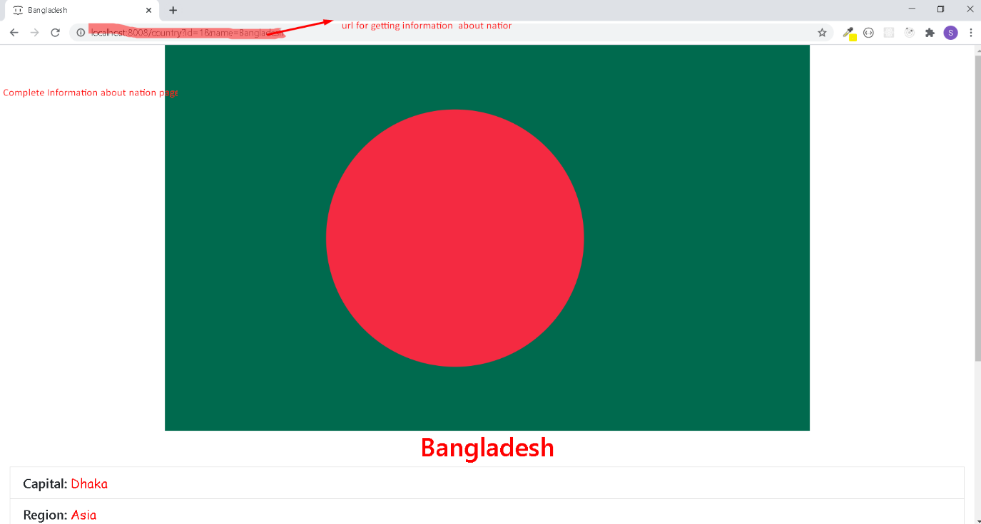

Back to Home Page Button returns to the main Page

